Email Listener in Pega

First we need to use the app studio for Email Bot configuration

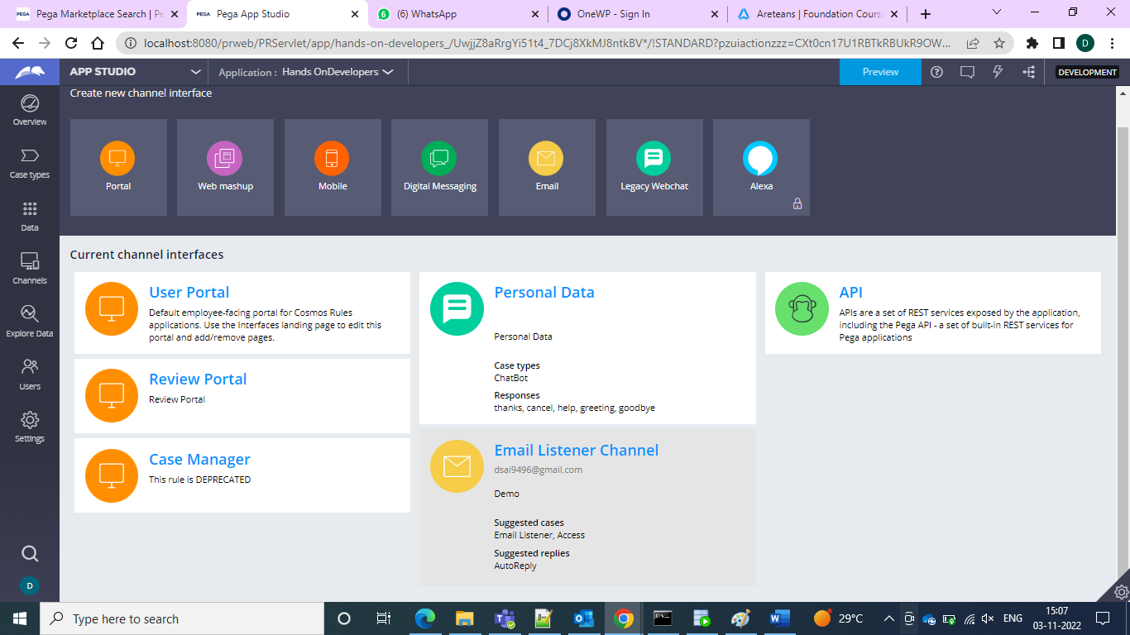

Click on Email and then we can use the email bot

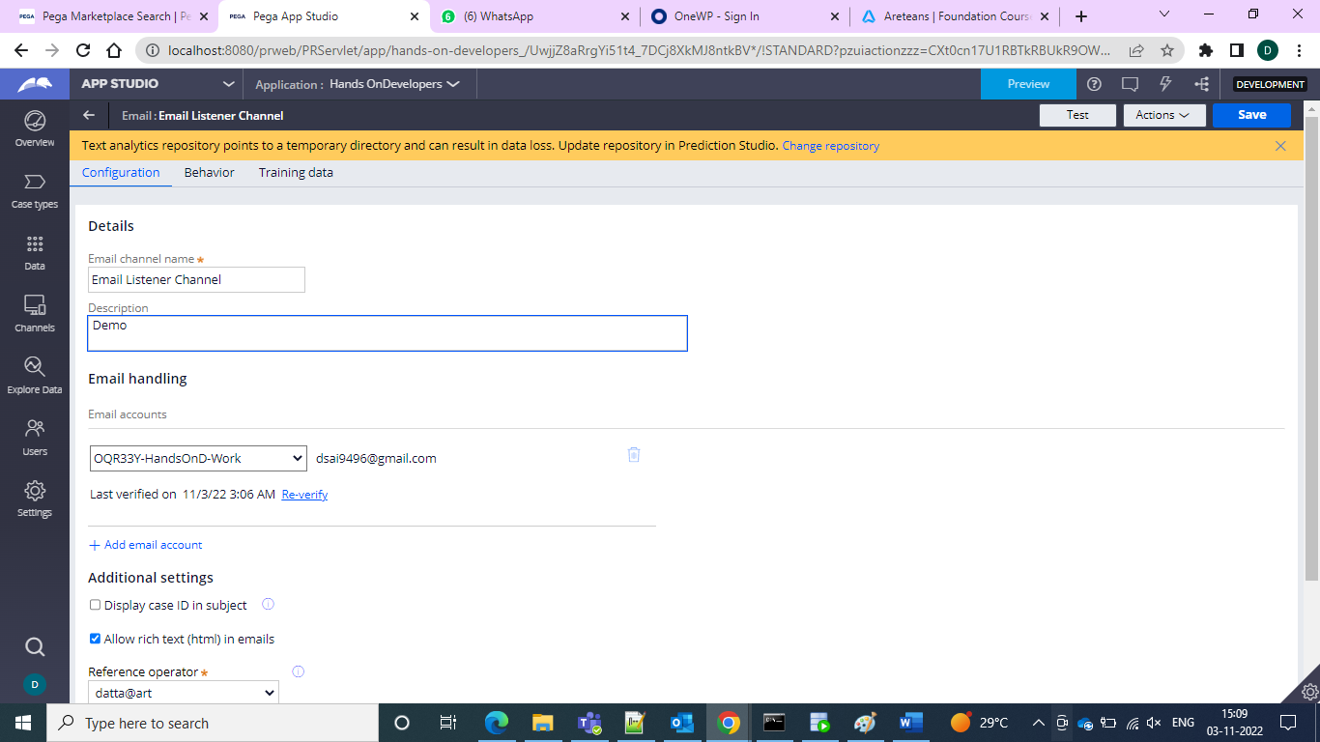

In the email channel name we have to give the channel name and description you can specify as per your requirement

And in the email Handling we need to give the email account which we would configure as email account from Integration resources.

And in the reference operator we need to give the operator with which we are log in or access which we have to the application.

In the behaviour we have the suggested cases we can add our case types which we created and add it there

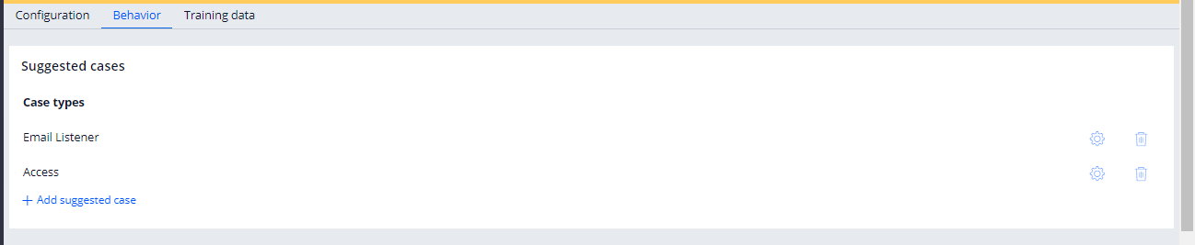

And in the suggested replies we need to give one template to identify the email and then go for the intelligent routing and then here we need to give the actions what that email listener must do

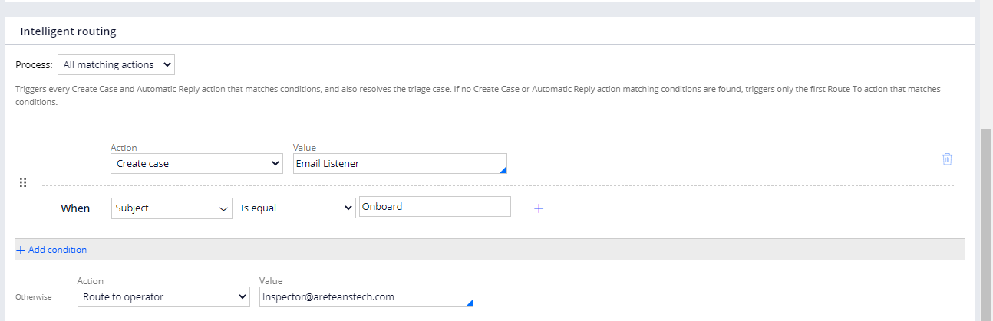

And in the admin studio we can go for checking the status of the Email Listener whether sleeping or running

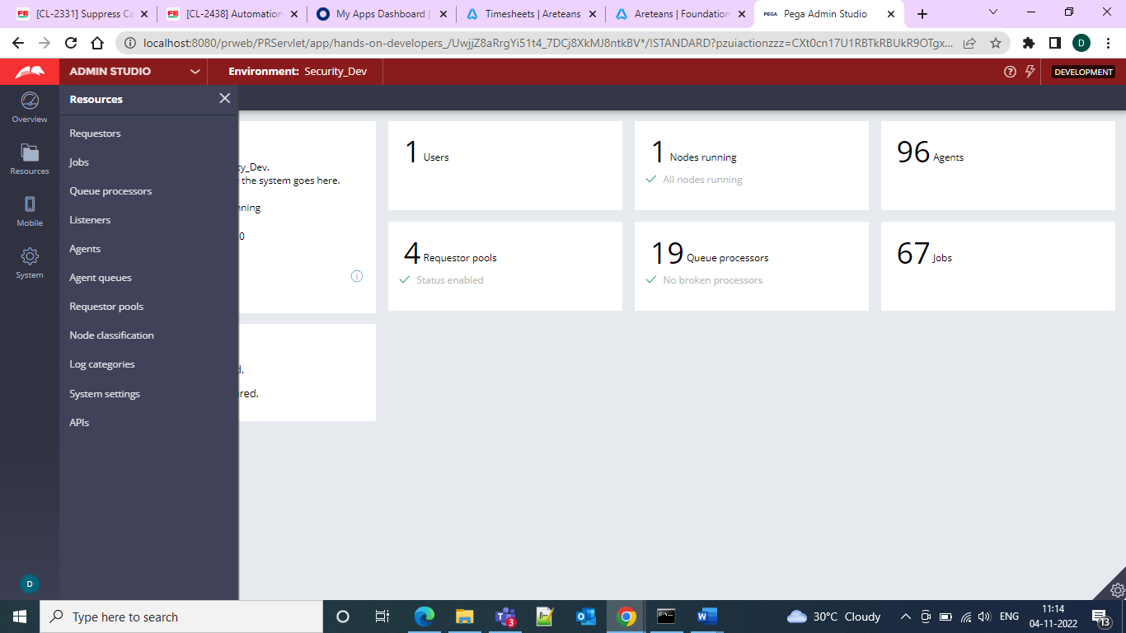

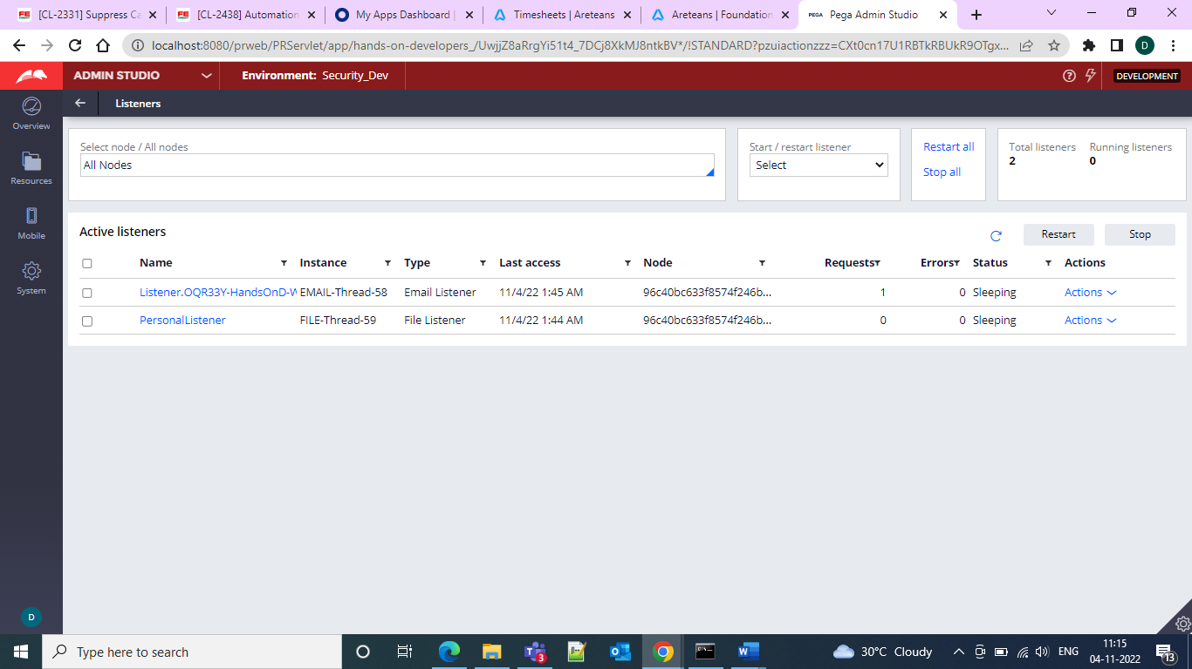

So afte this we need to restart our listener and then go for the sending of the email from any of the mail ID to the configured mail ID in our pega

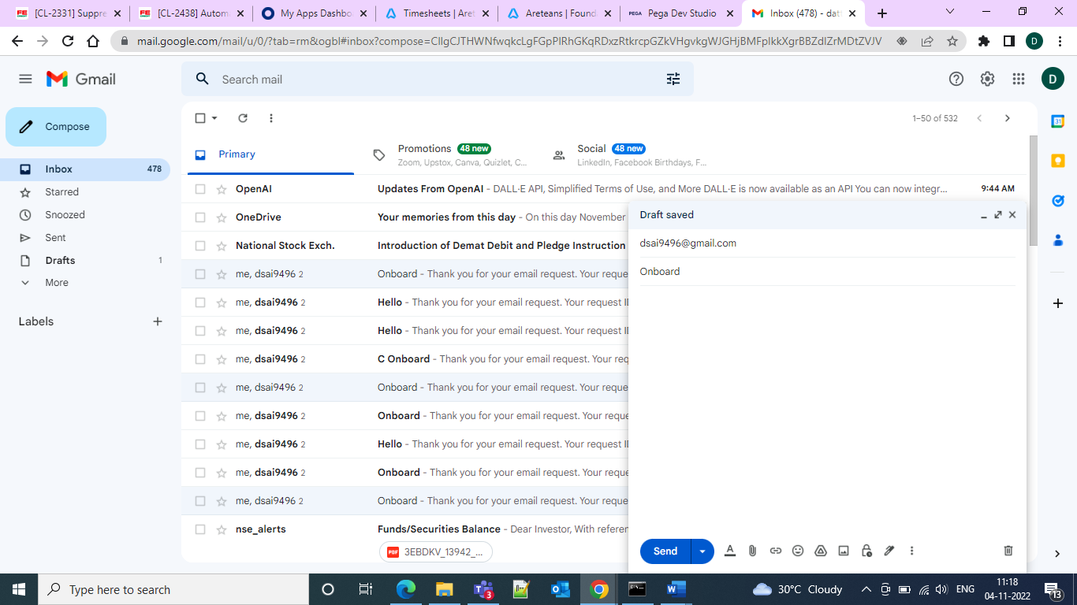

And then since we gave the subject as onboard a case should be created In your email listener case type instance

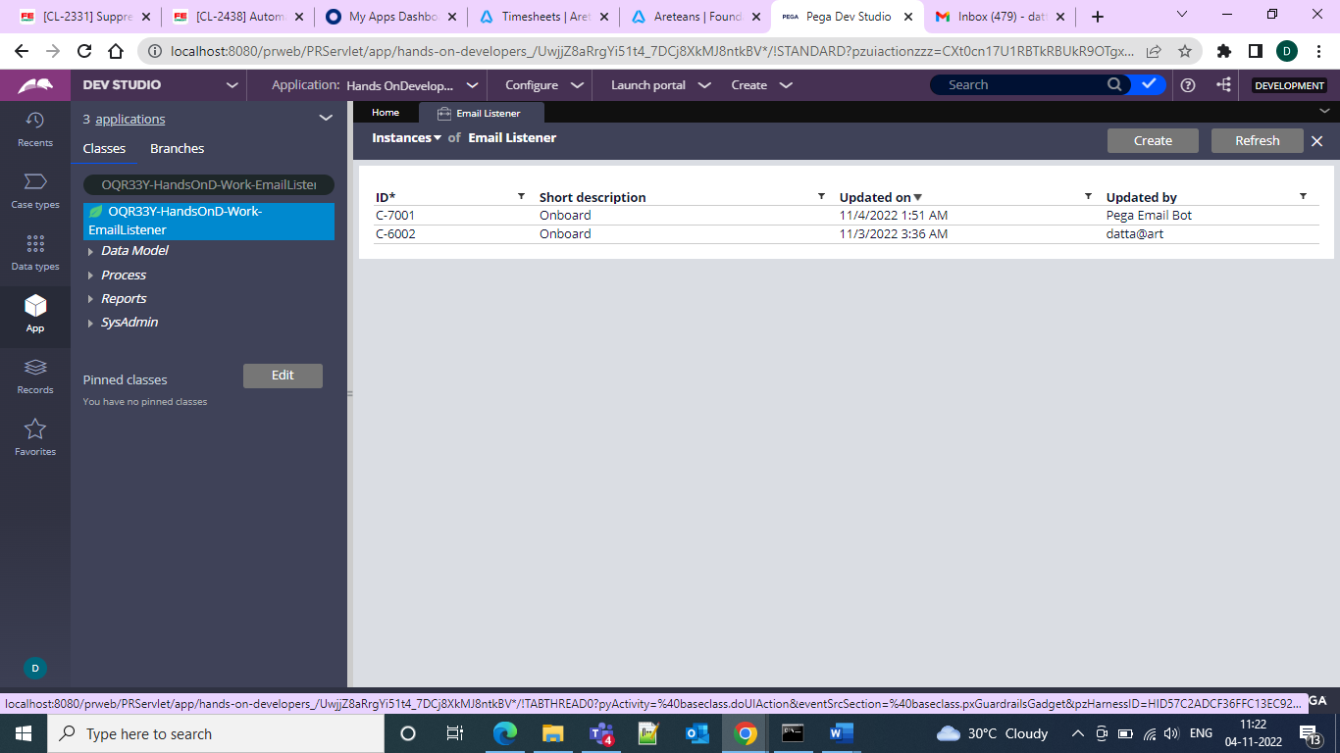

So here under the date 4th a case instance got created.

And when it is given as hello in the subject then it would be routed to the operator.

